Week 6 Networks and permissions

1. ping 10.10.10.1 while in lab

Ping command on server was successful, the command pings the router.

1. ping 10.10.10.55

Ping command was unsuccessful, the command couldn’t ping a device with specific IP Address.

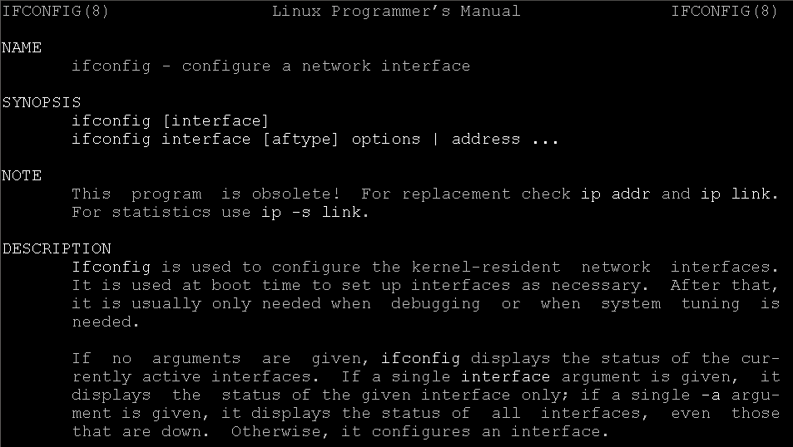Ifconfig shows information regarding to internet connection. (IP Address etc.)

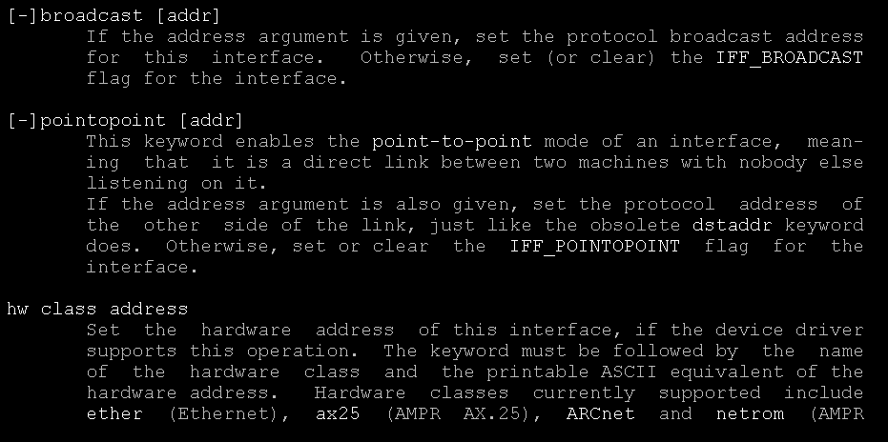

This screen shot shows additional commands that can be performed by ifconfig.

[msuriel6033@CISHavLAMP0 Lab6]$ chmod a=rw Lab6-1

[msuriel6033@CISHavLAMP0 Lab6]$ ls -l

total 4

-rw-rw-rw-. 1 msuriel6033 msuriel6033 0 Feb 25 18:20 Lab6-1

-rwxr--r--. 1 msuriel6033 msuriel6033 0 Feb 25 18:28 Lab6-2

----------. 1 msuriel6033 msuriel6033 0 Feb 25 18:37 Lab6-3

-rw-rw-r--. 1 msuriel6033 msuriel6033 0 Feb 25 18:37 Lab6-4

-r-xr--r--. 1 msuriel6033 msuriel6033 0 Feb 25 18:37 Lab6-5

drwxrwxr-x. 2 msuriel6033 msuriel6033 4096 Feb 25 18:43 test

[msuriel6033@CISHavLAMP0 Lab6]$ chmod u=rwx,g=r,o=r Lab6-2

[msuriel6033@CISHavLAMP0 Lab6]$ ls -l

total 4

-rw-rw-rw-. 1 msuriel6033 msuriel6033 0 Feb 25 18:20 Lab6-1

-rwxr--r--. 1 msuriel6033 msuriel6033 0 Feb 25 18:28 Lab6-2

----------. 1 msuriel6033 msuriel6033 0 Feb 25 18:37 Lab6-3

-rw-rw-r--. 1 msuriel6033 msuriel6033 0 Feb 25 18:37 Lab6-4

-r-xr--r--. 1 msuriel6033 msuriel6033 0 Feb 25 18:37 Lab6-5

drwxrwxr-x. 2 msuriel6033 msuriel6033 4096 Feb 25 18:43 test

[msuriel6033@CISHavLAMP0 Lab6]$ chmod a= Lab6-3

[msuriel6033@CISHavLAMP0 Lab6]$ ls -l

total 4

-rw-rw-rw-. 1 msuriel6033 msuriel6033 0 Feb 25 18:20 Lab6-1

-rwxr--r--. 1 msuriel6033 msuriel6033 0 Feb 25 18:28 Lab6-2

----------. 1 msuriel6033 msuriel6033 0 Feb 25 18:37 Lab6-3

-rw-rw-r--. 1 msuriel6033 msuriel6033 0 Feb 25 18:37 Lab6-4

-r-xr--r--. 1 msuriel6033 msuriel6033 0 Feb 25 18:37 Lab6-5

drwxrwxr-x. 2 msuriel6033 msuriel6033 4096 Feb 25 18:43 test

[msuriel6033@CISHavLAMP0 Lab6]$ chmod u=rw,g=rw,o=r Lab6-4

[msuriel6033@CISHavLAMP0 Lab6]$ ls -l

total 4

-rw-rw-rw-. 1 msuriel6033 msuriel6033 0 Feb 25 18:20 Lab6-1

-rwxr--r--. 1 msuriel6033 msuriel6033 0 Feb 25 18:28 Lab6-2

----------. 1 msuriel6033 msuriel6033 0 Feb 25 18:37 Lab6-3

-rw-rw-r--. 1 msuriel6033 msuriel6033 0 Feb 25 18:37 Lab6-4

-r-xr--r--. 1 msuriel6033 msuriel6033 0 Feb 25 18:37 Lab6-5

drwxrwxr-x. 2 msuriel6033 msuriel6033 4096 Feb 25 18:43 test

[msuriel6033@CISHavLAMP0 Lab6]$

Display all 1079 possibilities? (y or n)

[msuriel6033@CISHavLAMP0 Lab6]$ chmod u=rx,g=r,o=r Lab6-5

[msuriel6033@CISHavLAMP0 Lab6]$ ls -l

total 4

-rw-rw-rw-. 1 msuriel6033 msuriel6033 0 Feb 25 18:20 Lab6-1

-rwxr--r--. 1 msuriel6033 msuriel6033 0 Feb 25 18:28 Lab6-2

----------. 1 msuriel6033 msuriel6033 0 Feb 25 18:37 Lab6-3

-rw-rw-r--. 1 msuriel6033 msuriel6033 0 Feb 25 18:37 Lab6-4

-r-xr--r--. 1 msuriel6033 msuriel6033 0 Feb 25 18:37 Lab6-5

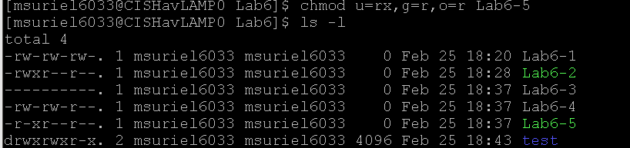drwxrwxr-x. 2 msuriel6033 msuriel6033 4096 Feb 25 18:43 test

1 Everyone can read and write but not execute

2 Owner has full permissions but everyone else can only read

3 No one can do anything including the owner

4 Owner and group have read and write permission, public only has read

5 Owner can read and execute but not write, everyone else can read